Unit-5: Data Visualization using dataframe:

5.1 importing matplotlib.pyplot and plotting: ( only two dimensional Plots)

Pyplot

Most of the Matplotlib utilities lies under the pyplot submodule, and are usually imported under the plt alias:

import matplotlib.pyplot as plt

Now the Pyplot package can be referred to as plt.

Example

Draw a line in a diagram from position (0,0) to position (6,250):

import matplotlib.pyplot as plt  
import numpy as np  
  
xpoints = np.array([0, 6])  
ypoints = np.array([0, 250])  
  
plt.plot(xpoints, ypoints)  
plt.show()

Result:

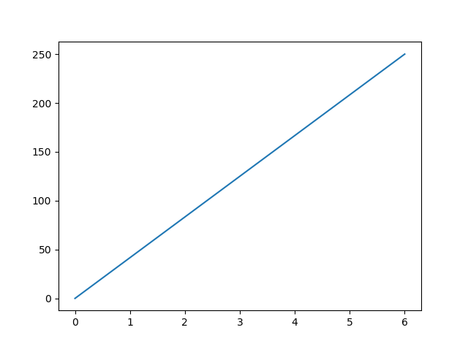

# **Python range() Function**

### Example

Create a sequence of numbers from 0 to 5, and print each item in the sequence:

x = range(6)  
for n in x:  
  print(n)

## Definition and Usage

The range() function returns a sequence of numbers, starting from 0 by default, and increments by 1 (by default), and stops before a specified number.

## Syntax

range(start, stop, step)

## Parameter Values

|  |  |
| --- | --- |
| **Parameter** | **Description** |
| start | Optional. An integer number specifying at which position to start. Default is 0 |
| stop | Required. An integer number specifying at which position to stop (not included). |
| step | Optional. An integer number specifying the incrementation. Default is 1 |

## More Examples

### Example

Create a sequence of numbers from 3 to 5, and print each item in the sequence:

x = range(3, 6)  
for n in x:  
  print(n)

### Example

Create a sequence of numbers from 3 to 19, but increment by 2 instead of 1:

x = range(3, 20, 2)  
for n in x:  
  print(n)

# **Subplots() Function**

Matplotlib’spyplot API has a convenience function called subplots() which acts as a utility wrapper and helps in creating common layouts of subplots, including the enclosing figure object, in a single call.

Plt.subplots(nrows, ncols)

The two integer arguments to this function specify the number of rows and columns of the subplot grid. The function returns a figure object and a tuple containing axes objects equal to nrows*ncols. Each axes object is accessible by its index. Here we create a subplot of 2 rows by 2 columns and display 4 different plots in each subplot.

import matplotlib.pyplot as plt

fig,a = plt.subplots(2,2)

import numpy as np

x = np.arange(1,5)

a[0][0].plot(x,x*x)

a[0][0].set_title('square')

a[0][1].plot(x,np.sqrt(x))

a[0][1].set_title('square root')

a[1][0].plot(x,np.exp(x))

a[1][0].set_title('exp')

a[1][1].plot(x,np.log10(x))

a[1][1].set_title('log')

plt.show()

The above line of code generates the following output −

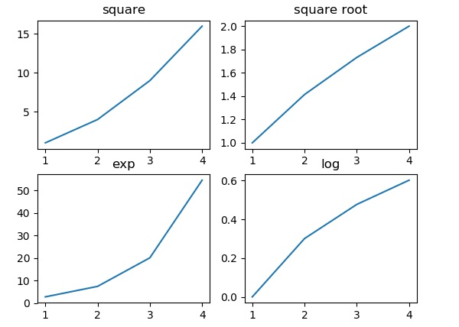

# Matplotlib.pyplot.legend() in Python

* **Difficulty Level :** [Basic](https://www.geeksforgeeks.org/basic/)
* **Last Updated :** 12 Apr, 2020

**Matplotlib** is one of the most popular Python packages used for data visualization. It is a cross-platform library for making 2D plots from data in arrays. **Pyplot** is a collection of command style functions that make matplotlib work like MATLAB. Each pyplot function makes some change to a figure: e.g., creates a figure, creates a plotting area in a figure, plots some lines in a plotting area, decorates the plot with labels, etc.

## Matplotlib.pyplot.legend()

A legend is an area describing the elements of the graph. In the matplotlib library, there’s a function called **legend()** which is used to Place a legend on the axes.

The attribute **Loc** in legend() is used to specify the location of the legend.Default value of loc is loc=”best” (upper left). The strings ‘upper left’, ‘upper right’, ‘lower left’, ‘lower right’ place the legend at the corresponding corner of the axes/figure.

The attribute **bbox_to_anchor=(x, y)** of legend() function is used to specify the coordinates of the legend, and the attribute **ncol** represents the number of columns that the legend has.It’s default value is 1.

**Syntax:**

*matplotlib.pyplot.legend([“blue”, “green”], bbox_to_anchor=(0.75, 1.15), ncol=2)*

The Following are some more attributes of function legend() :

* **shadow**: [None or bool] Whether to draw a shadow behind the legend.It’s Default value is None.
* **markerscale**: [None or int or float] The relative size of legend markers compared with the originally drawn ones.The Default is None.
* **numpoints**: [None or int] The number of marker points in the legend when creating a legend entry for a Line2D (line).The Default is None.
* **fontsize**: The font size of the legend.If the value is numeric the size will be the absolute font size in points.
* **facecolor**: [None or “inherit” or color] The legend’s background color.
* **edgecolor**: [None or “inherit” or color] The legend’s background patch edge color.

#### Ways to use legend() function in Python –

**Example 1:**

|  |
| --- |
| **import** numpy as np  **import** matplotlib.pyplot as plt    # X-axis values  x **=** [1, 2, 3, 4, 5]    # Y-axis values  y **=** [1, 4, 9, 16, 25]    # Function to plot  plt.plot(x, y)    # Function add a legend  plt.legend(['single element'])    # function to show the plot  plt.show() |

**Output :**  
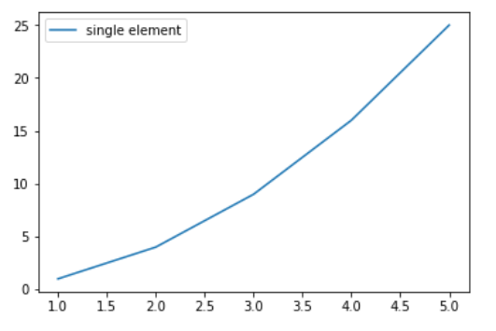

**Example 2:**

|  |
| --- |
| # importing modules  **import** numpy as np  **import** matplotlib.pyplot as plt    # Y-axis values  y1 **=** [2, 3, 4.5]    # Y-axis values  y2 **=** [1, 1.5, 5]    # Function to plot  plt.plot(y1)  plt.plot(y2)    # Function add a legend  plt.legend(["blue", "green"], loc **=**"lower right")    # function to show the plot  plt.show() |

**Output :**  
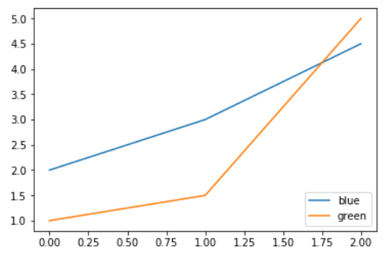

**Example 3:**

|  |
| --- |
| **import** numpy as np  **import** matplotlib.pyplot as plt    # X-axis values  x **=** np.arange(5)    # Y-axis values  y1 **=** [1, 2, 3, 4, 5]    # Y-axis values  y2 **=** [1, 4, 9, 16, 25]    # Function to plot  plt.plot(x, y1, label **=**'Numbers')  plt.plot(x, y2, label **=**'Square of numbers')    # Function add a legend  plt.legend()    # function to show the plot  plt.show() |

**Output :**  
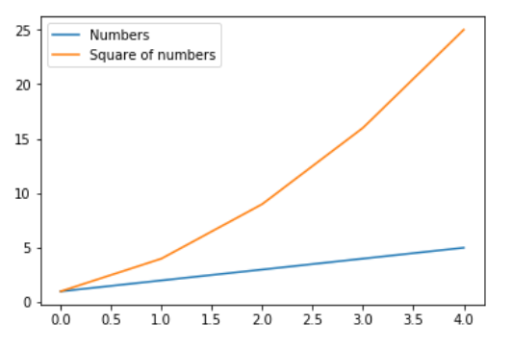

**Example 4:**

|  |
| --- |
| **import** numpy as np  **import** matplotlib.pyplot as plt    x **=** np.linspace(0, 10, 1000)  fig, ax **=** plt.subplots()    ax.plot(x, np.sin(x), '--b', label **=**'Sine')  ax.plot(x, np.cos(x), c **=**'r', label **=**'Cosine')  ax.axis('equal')    leg **=** ax.legend(loc **=**"lower left"); |

**Output:**  
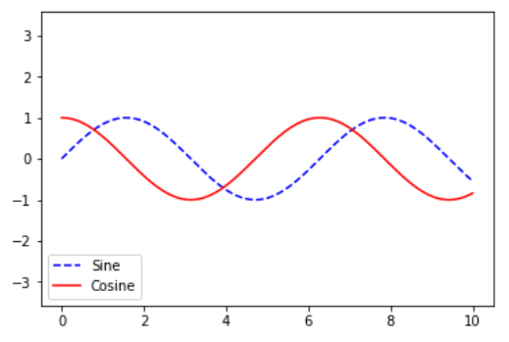

**Example 5:**

|  |
| --- |
| # importing modules  **import** numpy as np  **import** matplotlib.pyplot as plt    # X-axis values  x **=** [0, 1, 2, 3, 4, 5, 6, 7, 8]    # Y-axis values  y1 **=** [0, 3, 6, 9, 12, 15, 18, 21, 24]  # Y-axis values  y2 **=** [0, 1, 2, 3, 4, 5, 6, 7, 8]    # Function to plot  plt.plot(y1, label **=**"y = x")  plt.plot(y2, label **=**"y = 3x")    # Function add a legend  plt.legend(bbox_to_anchor **=**(0.75, 1.15), ncol **=** 2)    # function to show the plot  plt.show() |

**Output:**  
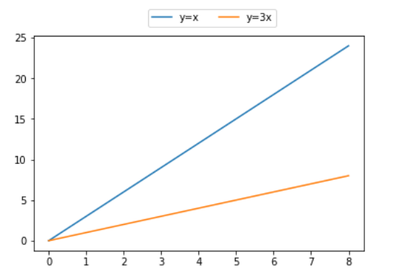

Pandas DataFrame is a two-dimensional size-mutable, potentially heterogeneous tabular data structure with labeled axes (rows and columns). Arithmetic operations align on both row and column labels. It can be thought of as a dict-like container for Series objects. This is the primary data structure of the Pandas.

Pandas**DataFrame.columns** attribute return the column labels of the given Dataframe.

***Syntax:****DataFrame.columns*

***Parameter :****None*

***Returns :****column names*

**Example #1:** Use DataFrame.columns attribute to return the column labels of the given Dataframe.

|  |
| --- |
| # importing pandas as pd  **import** pandas as pd    # Creating the DataFrame  df **=** pd.DataFrame({'Weight':[45, 88, 56, 15, 71],                     'Name':['Sam', 'Andrea', 'Alex', 'Robin', 'Kia'],                     'Age':[14, 25, 55, 8, 21]})    # Create the index  index_ **=** ['Row_1', 'Row_2', 'Row_3', 'Row_4', 'Row_5']    # Set the index  df.index **=** index_    # Print the DataFrame  print(df) |

**Output :**  
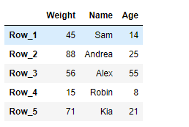

Now we will use DataFrame.columns attribute to return the column labels of the given dataframe.

|  |
| --- |
| # return the column labels  result **=** df.columns    # Print the result  print(result) |

**Output :**  
  
As we can see in the output, the DataFrame.columns attribute has successfully returned all of the column labels of the given dataframe.  
   
**Example #2:** Use DataFrame.columns attribute to return the column labels of the given Dataframe.

|  |
| --- |
| # importing pandas as pd  **import** pandas as pd    # Creating the DataFrame  df **=** pd.DataFrame({"A":[12, 4, 5, None, 1],                     "B":[7, 2, 54, 3, None],                     "C":[20, 16, 11, 3, 8],                     "D":[14, 3, None, 2, 6]})    # Create the index  index_ **=** ['Row_1', 'Row_2', 'Row_3', 'Row_4', 'Row_5']    # Set the index  df.index **=** index_    # Print the DataFrame  print(df) |

**Output :**

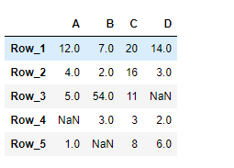

Now we will use DataFrame.columns attribute to return the column labels of the given dataframe.

|  |
| --- |
| # return the column labels  result **=** df.columns    # Print the result  print(result) |

**Output :**  
  
As we can see in the output, the DataFrame.columns attribute has successfully returned all of the column labels of the given dataframe.

# **Python len() Function**

### Example

Return the number of items in a list:

mylist = ["apple", "banana", "cherry"]  
x = len(mylist)

## Definition and Usage

The len() function returns the number of items in an object.

When the object is a string, the len() function returns the number of characters in the string.

## Syntax

len(object)

## Parameter Values

|  |  |
| --- | --- |
| **Parameter** | **Description** |
| object | Required. An object. Must be a sequence or a collection |

## More Examples

### Example

Return the number of characters in a string:

mylist = "Hello"  
x = len(mylist)

# matplotlib.pyplot.scatter() in Python

* **Last Updated :** 15 Feb, 2022

**Matplotlib** is a comprehensive library for creating static, animated, and interactive visualizations in Python. It is used for plotting various plots in Python like scatter plot, bar charts, pie charts, line plots, histograms, 3-D plots and many more. We will learn about the scatter plot from the [matplotlib](https://www.geeksforgeeks.org/python-matplotlib-an-overview/) library.   
**Note:** For more information, refer to [Python Matplotlib – An Overview](http://geeksforgeeks.org/python-matplotlib-an-overview/)

## matplotlib.pyplot.scatter()

Scatter plots are used to observe relationship between variables and uses dots to represent the relationship between them. The **scatter()** method in the matplotlib library is used to draw a scatter plot. Scatter plots are widely used to represent relation among variables and how change in one affects the other.   
**Syntax**   
The syntax for scatter() method is given below:

*matplotlib.pyplot.scatter(x_axis_data, y_axis_data, s=None, c=None, marker=None, cmap=None, vmin=None, vmax=None, alpha=None, linewidths=None, edgecolors=None)*

The scatter() method takes in the following parameters: 

* **x_axis_data-** An array containing x-axis data
* **y_axis_data-** An array containing y-axis data
* **s-** marker size (can be scalar or array of size equal to size of x or y)
* **c-** color of sequence of colors for markers
* marker- marker style
* **cmap-** cmap name
* **linewidths-** width of marker border
* **edgecolor-** marker border color
* **alpha-** blending value, between 0 (transparent) and 1 (opaque)

Except x_axis_data and y_axis_data all other parameters are optional and their default value is None. Below are the scatter plot examples with various parameters.  
**Example 1:** This is the most basic example of a scatter plot. 

* Python3

|  |
| --- |
| **import** matplotlib.pyplot as plt      x **=**[5, 7, 8, 7, 2, 17, 2, 9,      4, 11, 12, 9, 6]    y **=**[99, 86, 87, 88, 100, 86,      103, 87, 94, 78, 77, 85, 86]    plt.scatter(x, y, c **=**"blue")    # To show the plot  plt.show() |

**Output** 

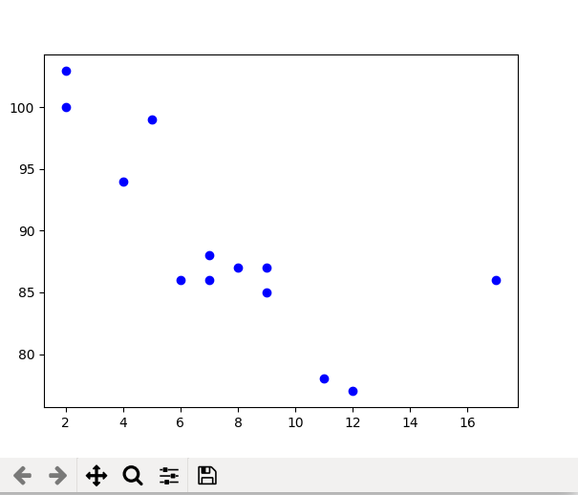

**Example 2:** Scatter plot with different shape and colour for two datasets. 

* Python3

|  |
| --- |
| **import** matplotlib.pyplot as plt    # dataset-1  x1 **=** [89, 43, 36, 36, 95, 10,        66, 34, 38, 20]    y1 **=** [21, 46, 3, 35, 67, 95,        53, 72, 58, 10]    # dataset2  x2 **=** [26, 29, 48, 64, 6, 5,        36, 66, 72, 40]    y2 **=** [26, 34, 90, 33, 38,        20, 56, 2, 47, 15]    plt.scatter(x1, y1, c **=**"pink",              linewidths **=** 2,              marker **=**"s",              edgecolor **=**"green",              s **=** 50)    plt.scatter(x2, y2, c **=**"yellow",              linewidths **=** 2,              marker **=**"^",              edgecolor **=**"red",              s **=** 200)    plt.xlabel("X-axis")  plt.ylabel("Y-axis")  plt.show() |

**Output** 

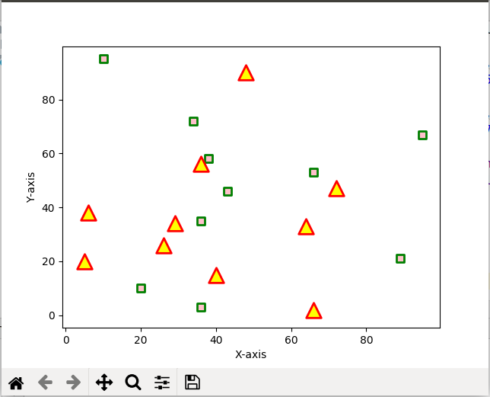

# Line chart in Matplotlib – Python

* **Difficulty Level :** [Medium](https://www.geeksforgeeks.org/medium/)
* **Last Updated :** 20 Oct, 2020

**Matplotlib** is a data visualization library in Python. The [**pyplot**](https://www.geeksforgeeks.org/pyplot-in-matplotlib/), a sublibrary of matplotlib, is a collection of functions that helps in creating a variety of charts.  ***Line charts***are used to represent the relation between two data X and Y on a different axis. Here we will see some of the examples of a line chart in Python :

## Simple line plots

First import Matplotlib.pyplot library for plotting functions. Also, import the Numpy library as per requirement. Then define data values x and y.

* Python3

|  |
| --- |
| # importing the required libraries  **import** matplotlib.pyplot as plt  **import** numpy as np    # define data values  x **=** np.array([1, 2, 3, 4])  # X-axis points  y **=** x**\***2  # Y-axis points    plt.plot(x, y)  # Plot the chart  plt.show()  # display |

**Output:**

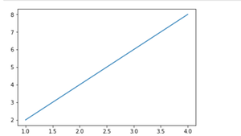

*Simple line plot between X and Y data*

we can see in the above output image that there is no label on the x-axis and y-axis. Since labeling is necessary for understanding the chart dimensions. In the following example, we will see how to add labels, Ident in the charts

* Python3

|  |
| --- |
| **import** matplotlib.pyplot as plt  **import** numpy as np      # Define X and Y variable data  x **=** np.array([1, 2, 3, 4])  y **=** x**\***2    plt.plot(x, y)  plt.xlabel("X-axis")  # add X-axis label  plt.ylabel("Y-axis")  # add Y-axis label  plt.title("Any suitable title")  # add title  plt.show() |

**Output:**

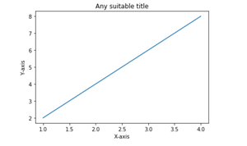

*Simple line plot with labels and title*

## Multiple charts

  We can display more than one chart in the same container by using [pyplot.figure()](https://www.geeksforgeeks.org/matplotlib-pyplot-figure-in-python/) function. This will help us in comparing the different charts and also control the look and feel of charts .

* Python3

|  |
| --- |
| **import** matplotlib.pyplot as plt  **import** numpy as np      x **=** np.array([1, 2, 3, 4])  y **=** x**\***2    plt.plot(x, y)  plt.xlabel("X-axis")  plt.ylabel("Y-axis")  plt.title("Any suitable title")  plt.show()  # show first chart    # The figure() function helps in creating a  # new figure that can hold a new chart in it.  plt.figure()  x1 **=** [2, 4, 6, 8]  y1 **=** [3, 5, 7, 9]  plt.plot(x1, y1, '-.')    # Show another chart with '-' dotted line  plt.show() |

**Output:**

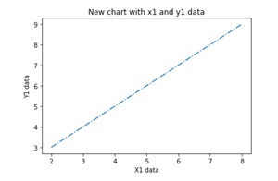

## Multiple plots on the same axis

Here we will see how to add 2 plots within the same axis.

* Python3

|  |
| --- |
| **import** matplotlib.pyplot as plt  **import** numpy as np    x **=** np.array([1, 2, 3, 4])  y **=** x**\***2    # first plot with X and Y data  plt.plot(x, y)    x1 **=** [2, 4, 6, 8]  y1 **=** [3, 5, 7, 9]    # second plot with x1 and y1 data  plt.plot(x1, y1, '-.')    plt.xlabel("X-axis data")  plt.ylabel("Y-axis data")  plt.title('multiple plots')  plt.show() |

**Output:**

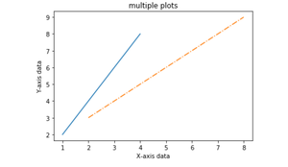

## Fill the area between two plots

Using the [pyplot.fill_between()](https://www.geeksforgeeks.org/matplotlib-pyplot-fill_between-in-python/) function we can fill in the region between two line plots in the same graph. This will help us in understanding the margin of data between two line plots based on certain conditions.

* Python3

|  |
| --- |
| **import** matplotlib.pyplot as plt  **import** numpy as np    x **=** np.array([1, 2, 3, 4])  y **=** x**\***2    plt.plot(x, y)    x1 **=** [2, 4, 6, 8]  y1 **=** [3, 5, 7, 9]    plt.plot(x, y1, '-.')  plt.xlabel("X-axis data")  plt.ylabel("Y-axis data")  plt.title('multiple plots')    plt.fill_between(x, y, y1, color**=**'green', alpha**=**0.5)  plt.show() |

**Output:**

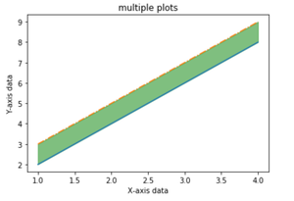

# Plotting Histogram in Python using Matplotlib

* **Difficulty Level :** [Easy](https://www.geeksforgeeks.org/easy/)
* **Last Updated :** 29 Jul, 2021

A histogram is basically used to represent data provided in a form of some groups.It is accurate method for the graphical representation of numerical data distribution.It is a type of bar plot where X-axis represents the bin ranges while Y-axis gives information about frequency.

## Creating a Histogram

To create a histogram the first step is to create bin of the ranges, then distribute the whole range of the values into a series of intervals, and count the values which fall into each of the intervals.Bins are clearly identified as consecutive, non-overlapping intervals of variables.The matplotlib.pyplot.hist() function is used to compute and create histogram of x.

The following table shows the parameters accepted by matplotlib.pyplot.hist() function :

| Attribute | parameter |
| --- | --- |
| x | array or sequence of array |
| bins | optional parameter contains integer or sequence or strings |
| density | optional parameter contains boolean values |
| range | optional parameter represents upper and lower range of bins |
| histtype | optional parameter used to create type of histogram [bar, barstacked, step, stepfilled], default is “bar” |
| align | optional parameter controls the plotting of histogram [left, right, mid] |
| weights | optional parameter contains array of weights having same dimensions as x |
| bottom | location of the basline of each bin |
| rwidth | optional parameter which is relative width of the bars with respect to bin width |
| color | optional parameter used to set color or sequence of color specs |
| label | optional parameter string or sequence of string to match with multiple datasets |
| log | optional parameter used to set histogram axis on log scale |

Let’s create a basic histogram of some random values. Below code creates a simple histogram of some random values:

* Python3

|  |
| --- |
| **from** matplotlib **import** pyplot as plt  **import** numpy as np      # Creating dataset  a **=** np.array([22, 87, 5, 43, 56,                73, 55, 54, 11,                20, 51, 5, 79, 31,                27])    # Creating histogram  fig, ax **=** plt.subplots(figsize **=**(10, 7))  ax.hist(a, bins **=** [0, 25, 50, 75, 100])    # Show plot  plt.show() |

**Output :**

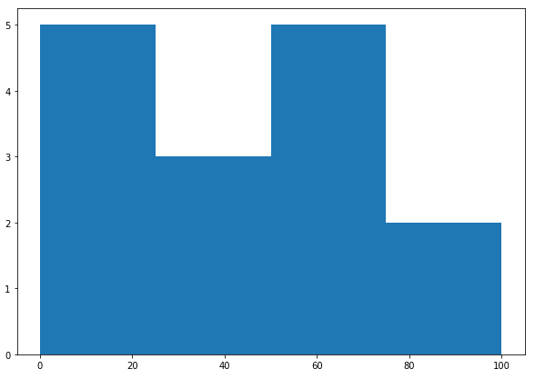

## Customization of Histogram

Matplotlib provides a range of different methods to customize histogram.   
matplotlib.pyplot.hist() function itself provides many attributes with the help of which we can modify a histogram.The hist() function provide a patches object which gives access to the properties of the created objects, using this we can modify the plot according to our will.

**Example 1:**

* Python3

|  |
| --- |
| **import** matplotlib.pyplot as plt  **import** numpy as np  **from** matplotlib **import** colors  **from** matplotlib.ticker **import** PercentFormatter    # Creating dataset  np.random.seed(23685752)  N_points **=** 10000  n_bins **=** 20    # Creating distribution  x **=** np.random.randn(N_points)  y **=** .8 **\*\*** x **+** np.random.randn(10000) **+** 25    # Creating histogram  fig, axs **=** plt.subplots(1, 1,                          figsize **=**(10, 7),                          tight_layout **=** True)    axs.hist(x, bins **=** n_bins)    # Show plot  plt.show() |

**Output :**

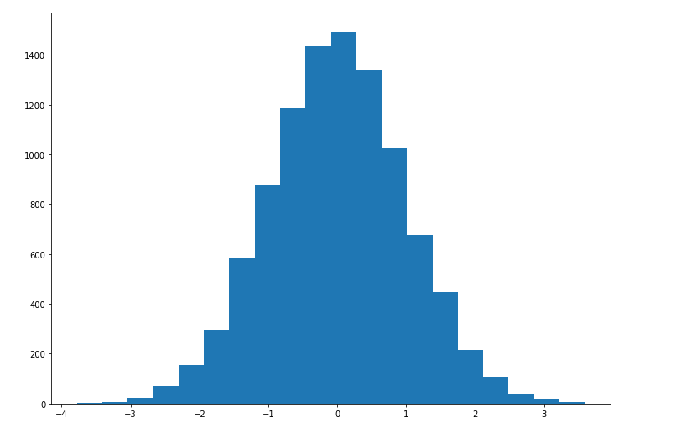

**Example 2:** The code below modifies the above histogram for a better view and accurate readings.

* Python3

|  |
| --- |
| **import** matplotlib.pyplot as plt  **import** numpy as np  **from** matplotlib **import** colors  **from** matplotlib.ticker **import** PercentFormatter      # Creating dataset  np.random.seed(23685752)  N_points **=** 10000  n_bins **=** 20    # Creating distribution  x **=** np.random.randn(N_points)  y **=** .8 **\*\*** x **+** np.random.randn(10000) **+** 25  legend **=** ['distribution']    # Creating histogram  fig, axs **=** plt.subplots(1, 1,                          figsize **=**(10, 7),                          tight_layout **=** True)      # Remove axes splines  **for** s **in** ['top', 'bottom', 'left', 'right']:      axs.spines[s].set_visible(False)    # Remove x, y ticks  axs.xaxis.set_ticks_position('none')  axs.yaxis.set_ticks_position('none')    # Add padding between axes and labels  axs.xaxis.set_tick_params(pad **=** 5)  axs.yaxis.set_tick_params(pad **=** 10)    # Add x, y gridlines  axs.grid(b **=** True, color **=**'grey',          linestyle **=**'-.', linewidth **=** 0.5,          alpha **=** 0.6)    # Add Text watermark  fig.text(0.9, 0.15, 'Jeeteshgavande30',           fontsize **=** 12,           color **=**'red',           ha **=**'right',           va **=**'bottom',           alpha **=** 0.7)    # Creating histogram  N, bins, patches **=** axs.hist(x, bins **=** n_bins)    # Setting color  fracs **=** ((N**\*\***(1 **/** 5)) **/** N.max())  norm **=** colors.Normalize(fracs.min(), fracs.max())    **for** thisfrac, thispatch **in** zip(fracs, patches):      color **=** plt.cm.viridis(norm(thisfrac))      thispatch.set_facecolor(color)    # Adding extra features  plt.xlabel("X-axis")  plt.ylabel("y-axis")  plt.legend(legend)  plt.title('Customized histogram')    # Show plot  plt.show() |

**Output :**

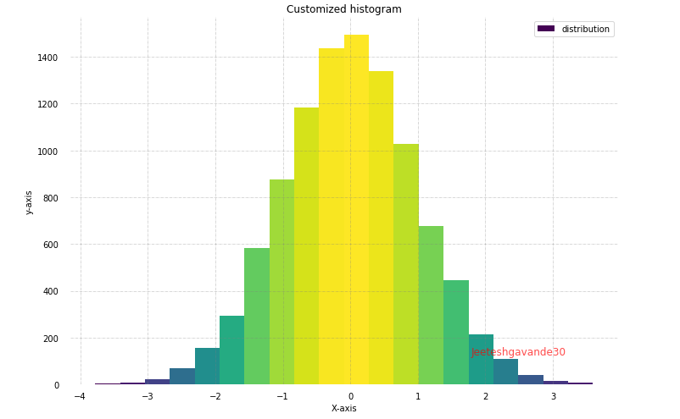

# **Matplotlib Bars**

[❮ Previous](https://www.w3schools.com/python/matplotlib_scatter.asp)[Next ❯](https://www.w3schools.com/python/matplotlib_histograms.asp)

## Creating Bars

With Pyplot, you can use the bar() function to draw bar graphs:

### Example

Draw 4 bars:

import matplotlib.pyplot as plt  
import numpy as np  
  
x = np.array(["A", "B", "C", "D"])  
y = np.array([3, 8, 1, 10])  
  
plt.bar(x,y)  
plt.show()

### Result:

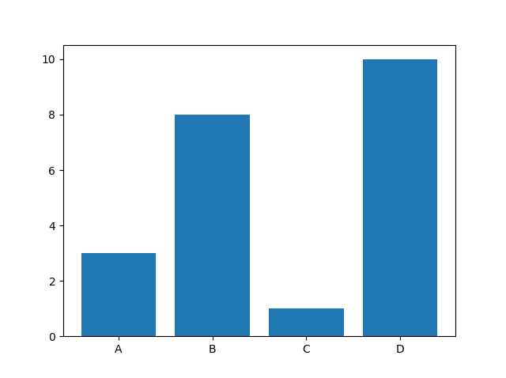

[Try it Yourself »](https://www.w3schools.com/python/trypython.asp?filename=demo_matplotlib_bars1)

The bar() function takes arguments that describes the layout of the bars.

The categories and their values represented by the first and second argument as arrays.

### Example

x = ["APPLES", "BANANAS"]  
y = [400, 350]  
plt.bar(x, y)

[Try it Yourself »](https://www.w3schools.com/python/trypython.asp?filename=demo_matplotlib_bars2)

ADVERTISEMENT

## Horizontal Bars

If you want the bars to be displayed horizontally instead of vertically, use the barh() function:

### Example

Draw 4 horizontal bars:

import matplotlib.pyplot as plt  
import numpy as np  
  
x = np.array(["A", "B", "C", "D"])  
y = np.array([3, 8, 1, 10])  
  
plt.barh(x, y)  
plt.show()

### Result:

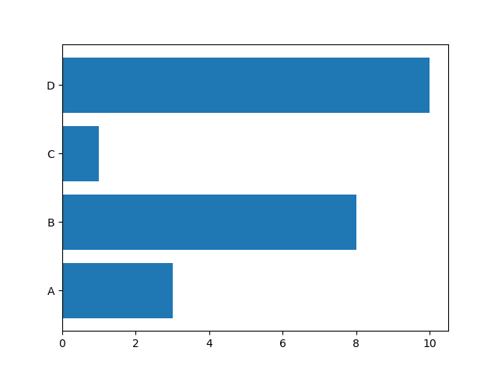

[Try it Yourself »](https://www.w3schools.com/python/trypython.asp?filename=demo_matplotlib_bars3)

## Bar Color

The bar() and barh() takes the keyword argument color to set the color of the bars:

### Example

Draw 4 red bars:

import matplotlib.pyplot as plt  
import numpy as np  
  
x = np.array(["A", "B", "C", "D"])  
y = np.array([3, 8, 1, 10])  
  
plt.bar(x, y, color = "red")  
plt.show()

### Result:

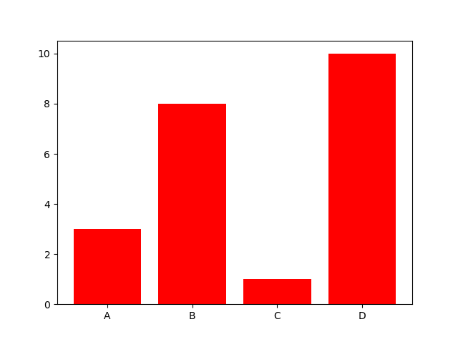

[Try it Yourself »](https://www.w3schools.com/python/trypython.asp?filename=demo_matplotlib_bars4)

### Color Names

You can use any of the [140 supported color names](https://www.w3schools.com/colors/colors_names.asp).

### Example

Draw 4 "hot pink" bars:

import matplotlib.pyplot as plt  
import numpy as np  
  
x = np.array(["A", "B", "C", "D"])  
y = np.array([3, 8, 1, 10])  
  
plt.bar(x, y, color = "hotpink")  
plt.show()

### Result:

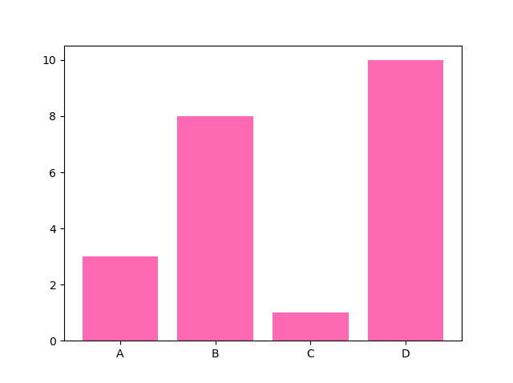

[Try it Yourself »](https://www.w3schools.com/python/trypython.asp?filename=demo_matplotlib_bars5)

### Color Hex

Or you can use [Hexadecimal color values](https://www.w3schools.com/colors/colors_hexadecimal.asp):

### Example

Draw 4 bars with a beautiful green color:

import matplotlib.pyplot as plt  
import numpy as np  
  
x = np.array(["A", "B", "C", "D"])  
y = np.array([3, 8, 1, 10])  
  
plt.bar(x, y, color = "#4CAF50")  
plt.show()

### Result:

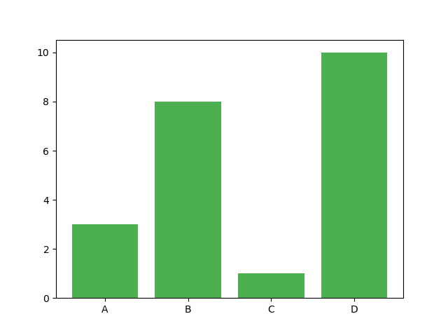

[Try it Yourself »](https://www.w3schools.com/python/trypython.asp?filename=demo_matplotlib_bars6)

## Bar Width

The bar() takes the keyword argument width to set the width of the bars:

### Example

Draw 4 very thin bars:

import matplotlib.pyplot as plt  
import numpy as np  
  
x = np.array(["A", "B", "C", "D"])  
y = np.array([3, 8, 1, 10])  
  
plt.bar(x, y, width = 0.1)  
plt.show()

### Result:

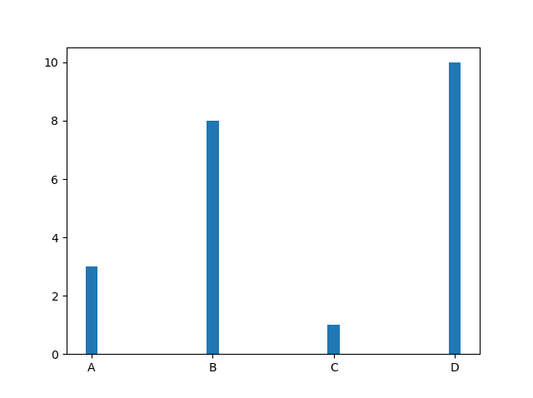

[Try it Yourself »](https://www.w3schools.com/python/trypython.asp?filename=demo_matplotlib_bars7)

The default width value is 0.8

**Note:** For horizontal bars, use height instead of width.

## Bar Height

The barh() takes the keyword argument height to set the height of the bars:

### Example

Draw 4 very thin bars:

import matplotlib.pyplot as plt  
import numpy as np  
  
x = np.array(["A", "B", "C", "D"])  
y = np.array([3, 8, 1, 10])  
  
plt.barh(x, y, height = 0.1)  
plt.show()

### Result:

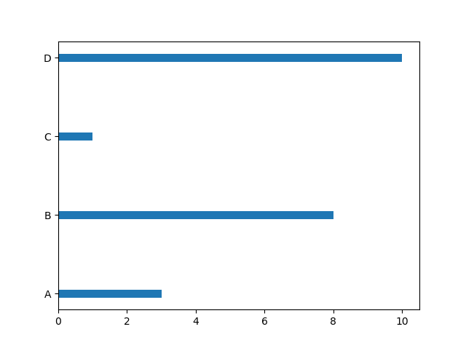

[Try it Yourself »](https://www.w3schools.com/python/trypython.asp?filename=demo_matplotlib_bars8)